Week 2

1. What is the String class in Java? Is String a data type?

= String class in java represent sequence of char values. Yes, String is a data type.

3. Can you use String in switch case in Java? Explain it briefly.

= Switch case in java is a multi-way branch statement. In simple words, it executes one statement from multiple conditions.

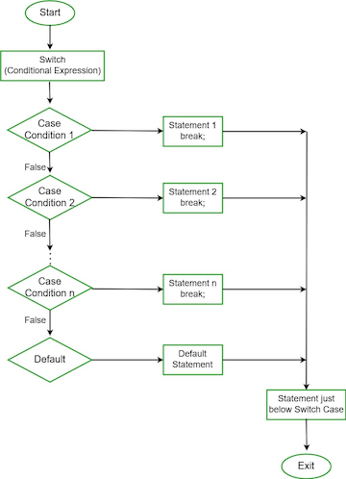

2. How can you make a String upper case or lower case in Java?

= Sting upper case

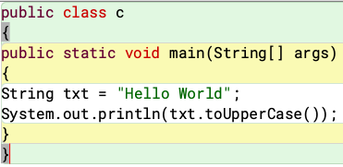

Output:



=String lower case

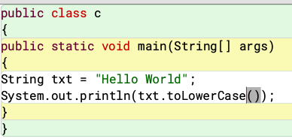

Output:



4. Explain different types of conditional statement in java.

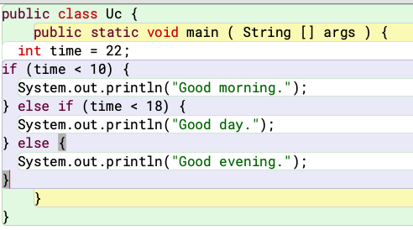

Output:



5. What is the value of the variable num after the following is

executed?

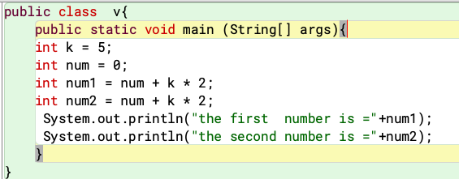

Output:

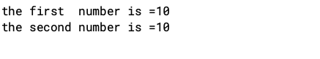

6. How do you split a string in Java?

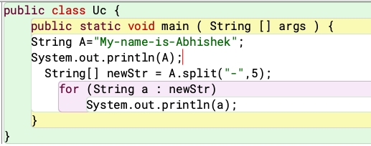

Output:

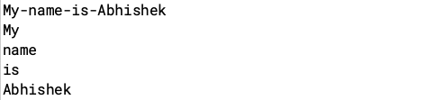

7. How do you check if two Strings are equal in Java?

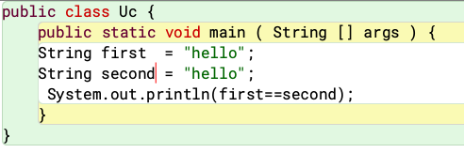

Output:

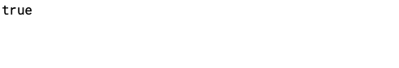

**Group B**

1. Find the difference between Beth’s age (57) and Tom’s age (34).

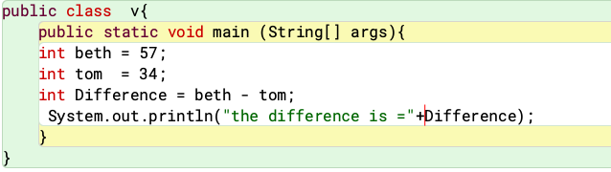

Output:

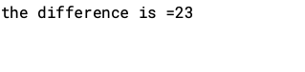

2. Develop a system to store your name as variable.

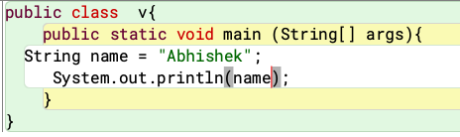

Output:

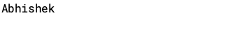

4. Find the difference between 7 factorial and 5 factorial.

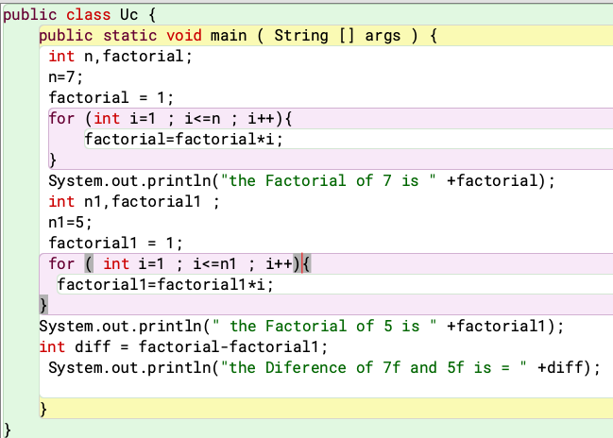

output:

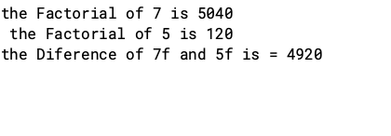

5. Complete the following questions by taking user input.

* Write a Java program that prompts a user for their last

name and stores it in a variable named last_name.

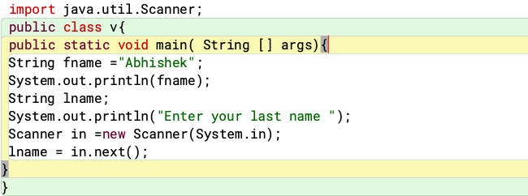

Output:

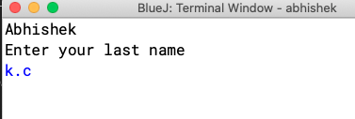

. Give an instruction that prompts a user for their age and stores it as an integer in a variable named age.

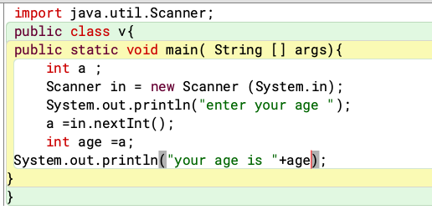

Output:

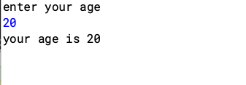

.Give an instruction that prompts a user for their temperature andstores it as a float in a variable named current_temperature.

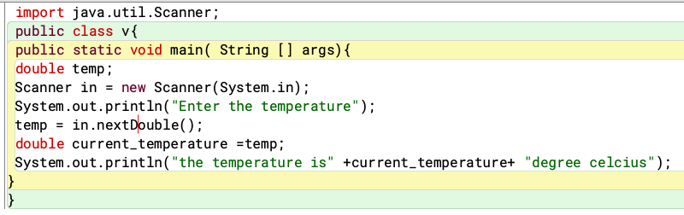output:

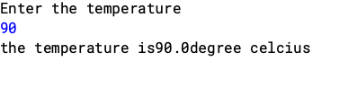

6. Give a call to printf that is provided one string that displays the

following address on three separate lines:

John Doe

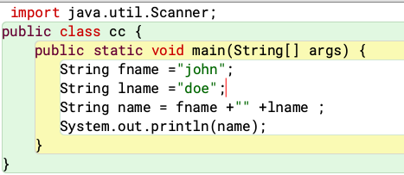

Output:

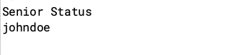

123 Dudley Street

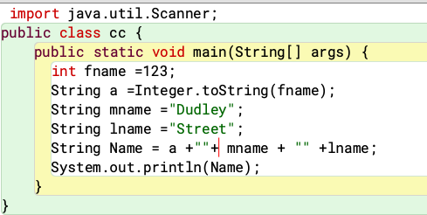

Output:



7. Write a java program in which:

c) A student enters the number of college credits earned. If the

number of credits is greater than or equal to 90, 'Senior

Status' is displayed; if greater than or equal to 60, 'Junior

Status' is displayed; if greater than or equal to 30,

'Sophomore Status' is displayed; else, 'Freshman Status' is

displayed.

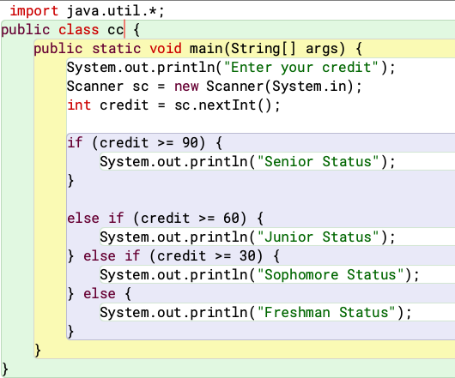

output:

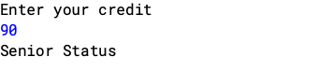

. Repeat question (a) using an (if statement with "else if" pairs)

instead.

a) The user enters either 'A', 'B', or 'C'. If 'A' is entered, the

program should display the word 'Apple'; if 'B' is entered, it

displays 'Banana'; and if 'C' is entered, it displays 'Coconut'.

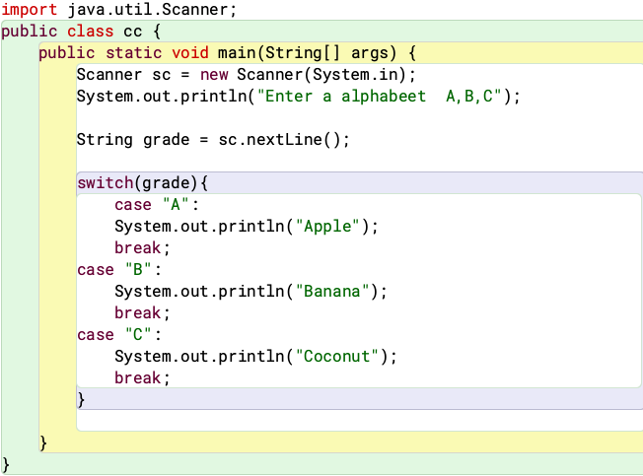

Output:

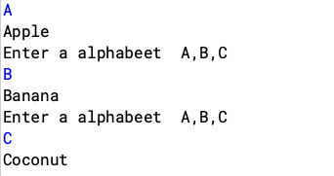

**Group c**

**1. Create a Java software that will ask the user for a number and then display whether it is positive or negative.**

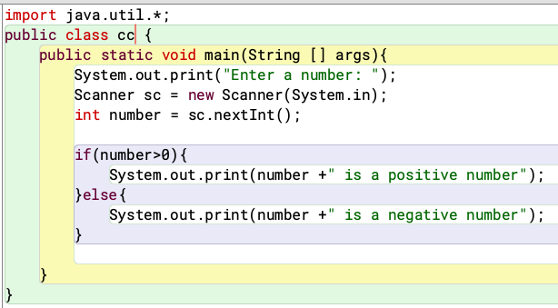

**Output:**

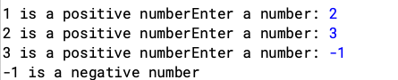

4. There were bunch of students who were curious about their total marks, percentage and grade using the marks from five subjects as input. Develop a system to help them find their grades.

Output:

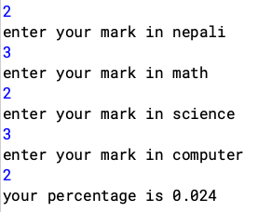

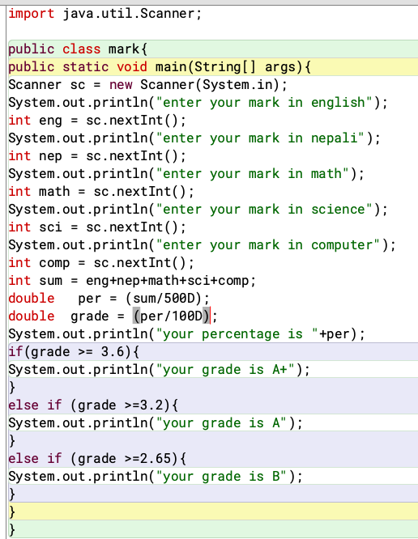

6. Let’s create a java program to input a number and check whether it is a Buzz number or not. A number is said to be a buzz number when it ends with 7 or is divisible by 7.

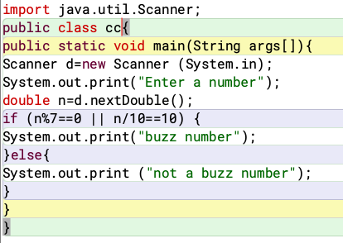

Output:

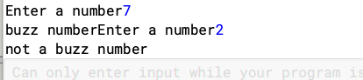

7. Let’s take an example program where we will take the age of user as input and find whether he is a child, adult, or senior on the basis of age. Using Java if-else-if ladder statements.

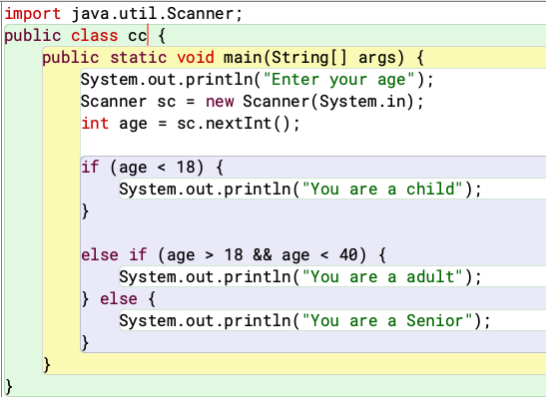

Output:

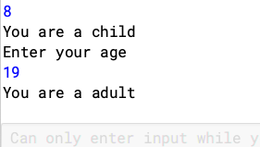

Group D

1. Let’s create a printing application program where we will take the number of copies to be printed as input from the user and then prints the price per copy and the total price for the printing copies.

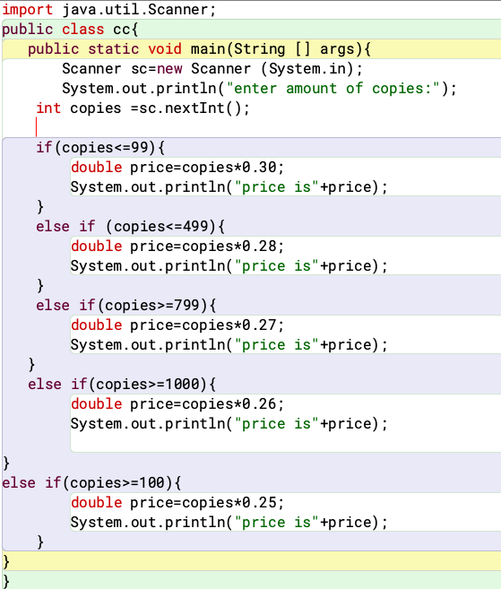

Output:

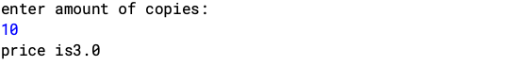

3. [Scenario] You’re waiting at a station and the announcer has just broadcast that your train is going to be 13445 seconds late. You need to work out in understandable terms what that means. You assume this is going to be quite a long time so you whip out your laptop to write a program to convert the seconds into hours, minutes and seconds, aiming to maximize readability by giving priority to the largest units, i.e. the resulting seconds and minute’s values must not be greater than 60.

You will need four variables to hold: the total number of seconds;

the number of hours; the number of minutes; and the number of remaining seconds. The example output should look something like

this:

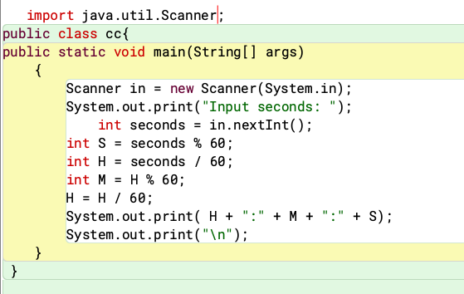

Output:

